Results

1. Obtaining the chassis.

Aiming to achieve MTS for environmental use, it is essential to make sure that when the MAT locus has DSB (double strands break) cleaved by HO, our type-a (MATa) yeast can only become type-α (MATα). Therefore, we used a Ura-tag to replace the HMR(a) domain in chromosome Ⅲ. In this way the HMR will no longer be the donor for the homologous recombination in the repairing process for MAT cleavage. Since the change of mating type may appear successively, there is a great possibility that the same type haploid mate with each other. To avoid the existence of meaningless mating, we built an vector to express MATα genes to produce a1-α2 stable corepressor so that the haploid will regard itself as a diploid and prevent mating unless the MATa locus changes to the other one. After selection, by homologous recombination, we deleted the Ura-tag for further usage. We selected the target colonies (**SynⅩ-dUra**) via 5Foa plates.

（插图）

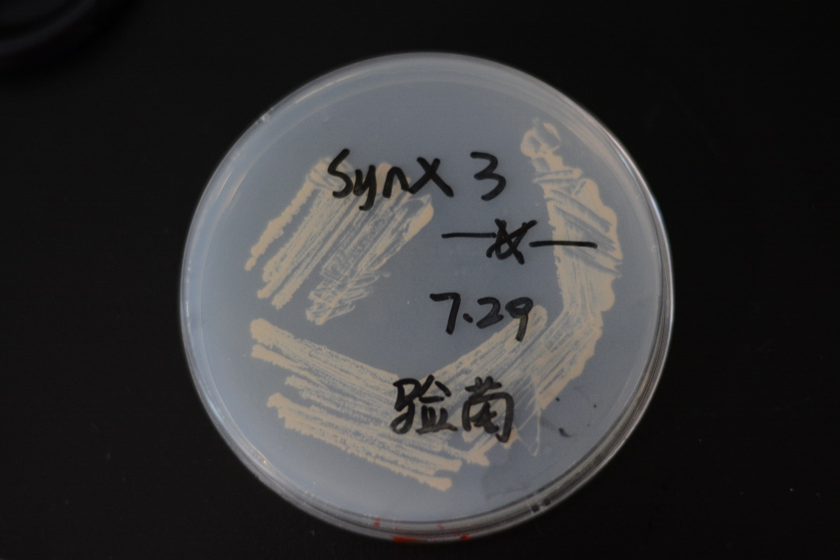

**Fig 1 We successfully acquired the target yeasts as our chassis (SynⅩ-dUra).**

（http://2017.igem.org/wiki/images/7/7e/Tianjin-ho-result-1.jpeg）

1. The result for constructing the Gal systems

In this pathway, we chose Gal1 as our inducible promoter for the expression of HO gene, CYC1 as the terminator, and PRS416(with Ura-tag) as our vector. As for segments ligation, we designed the cutting sites for Bsa1 enzyme in each part, hoping to achieve seamless ligation of these three parts.

We adopted the PCR method to amplify the Gal1-part and CYC1-part from a Gal1-Vika plasmid we had used in our former lab work with specially designed primers for this procedure. After PCR, the Gal1 has the cutting sites for SalⅠand BsaⅠon both ends, and CYC1 has that for BsaⅠand BamhⅠon both ends. Meanwhile, the HO gene was obtained by gene synthesis, flanked by specific hangtags for BsaⅠin order to be cohesive with Gal1 (upstream) and CYC1 (downstream). Thus, we have built our composite part (**GHC**).

After the ligation of **GHC** and PRS416 Plasmid (**GHC-416**), we transformed the E. coli for the augment of our new plasmid—— **GHC-416**. We examined the transformation result by PCR method to amplify the HO gene in the E. coli which we randomly selected in the plate. （插图）

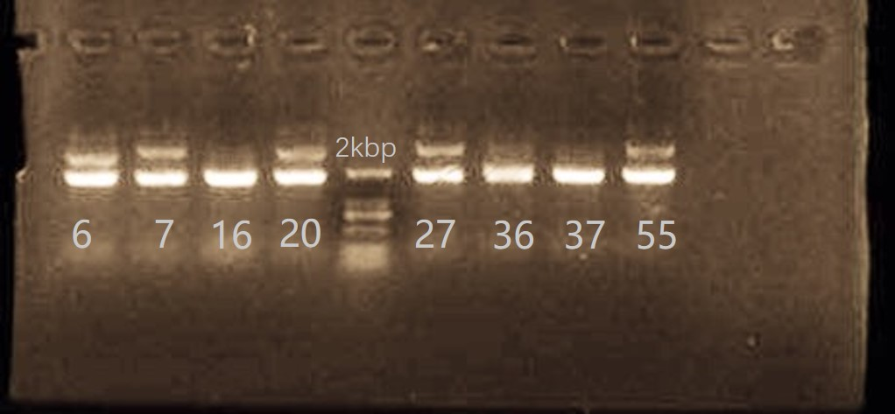

（http://2017.igem.org/wiki/images/6/68/Tianjin-ho-result-fig2.jpeg）

**Fig 2 The results of PCR of #6, #7, #16, #20, #27, #36, #37, #55 colonies. HO gene (length of 1770bp). As we can see, HO gene in all 8 colonies has been amplified, which indicated that we succeeded in constructing the device for HO gene expression.**

1. The result of mating type switching.

We transformed the chassis yeasts for the new device——**GHC-416**, the new yeasts we selected in the Sc-Ura plate is named as **SynⅩ-dUra-416.**

In this section, we only got to test the Gal System due to time limit. And we figured that the result for Gal System is adequately enough to represent the feasibility of our designed strategy for MTS.

The whole test process can be divided into three steps.

**Step1**: Activate the Gal1 promoter. After that, the expression of HO gene in the **SynⅩ-dUra-416** can be initiated. **Step2**: Cultivate two groups of yeasts together. (one is **SynⅩ-dUra-416,** the other is normal **BY4741 MATa**) If the MTS has been accomplished (**SynⅩ-dUra-416** can become MATα), the two groups of haploids can mate with each other and become diploids.  **Step3**: Test the results of mating by PCR method. We designed the primers for both MATa locus and MATα locus. The amplification of both MATa locus and MATα locus indicates that the yeasts has turned into diploids, the MTS has been achieved in other words.

According to our design, after activating the Gal1 promoter, the expression of HO gene in the **SynⅩ-dUra-416** can be initiated.

Then we cultivated two groups of yeasts together. (one is **SynⅩ-dUra-416,** the other is normal BY4741 MATa) If the MTS has been accomplished (**SynⅩ-dUra-416** can become MATα), the two groups of haploids can mate with each other and become diploids.

To test whether MTS has happened, we selected some colonies in the selective plates (Sc-Ura ) and adopted PCR method. With designed primers for both MATa locus and MATα locus, the amplification of both MATa locus and MATα locus can indicate that the yeasts has mated with each other, and turned into diploids, in other words, the MTS has been achieved. (插图)

（http://2017.igem.org/wiki/images/5/59/Tianjin-ho-result-fig3%28a%29.jpeg）

（http://2017.igem.org/wiki/images/f/f3/Tianjin-ho-result-fig3%28b%29.jpeg）

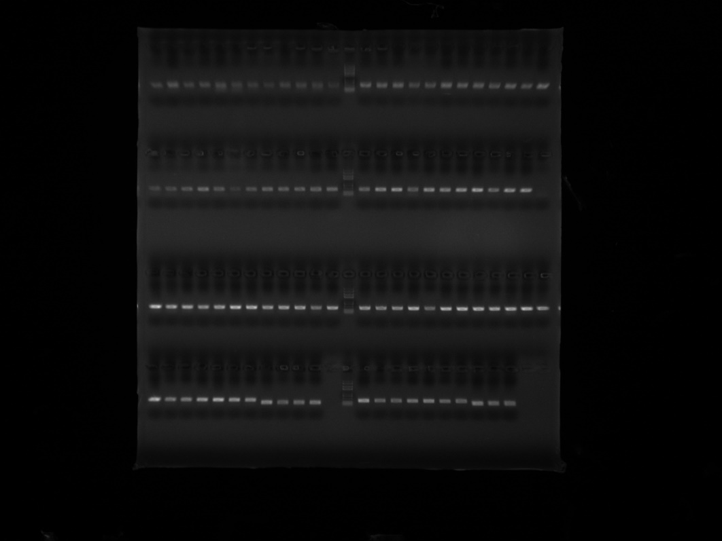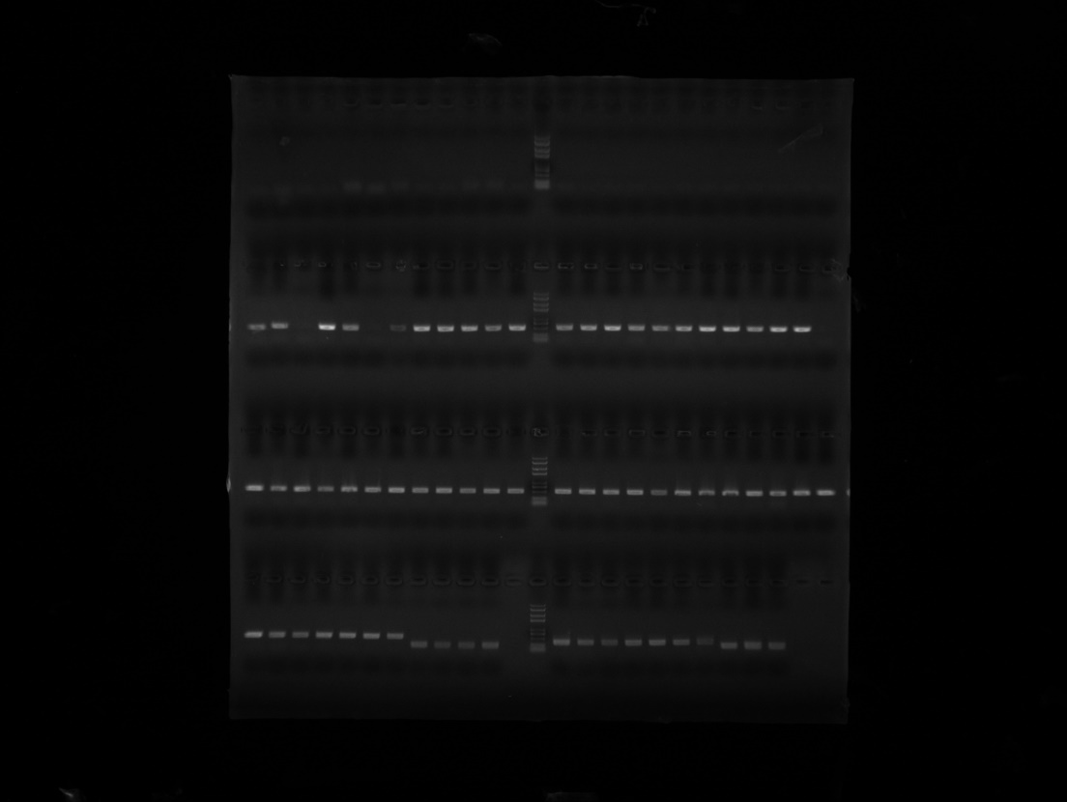

**Fig 3 (a) showed the PCR results for MATa locus. The MATa gene was amplified in all colonies except the first 24 colonies. (b)showed the PCR results for MATα locus. The MATα gene was amplified in all 96 colonies.**